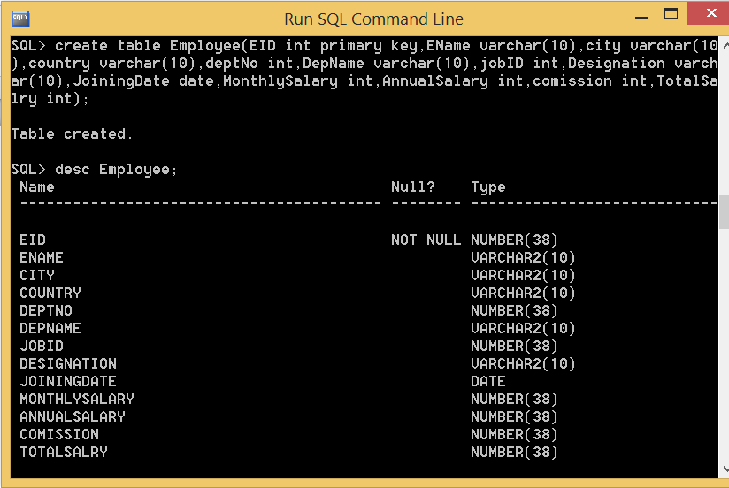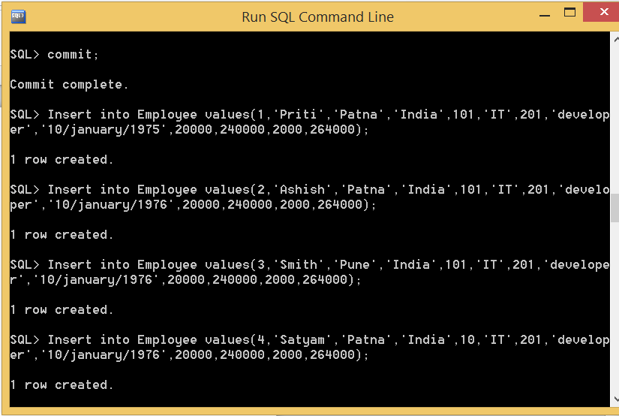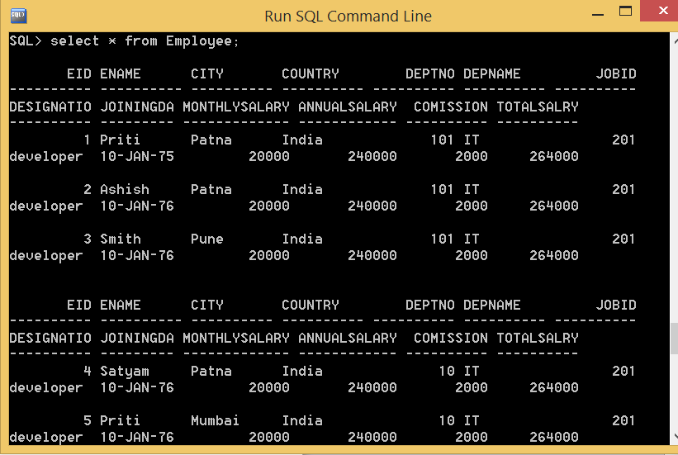

**SQL QUERIES**

**Q1. Display the details of SMITH**.

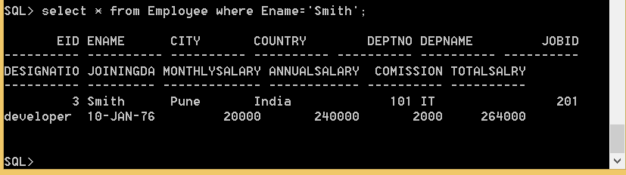

**2. Display unique Jobs from EMP table?**

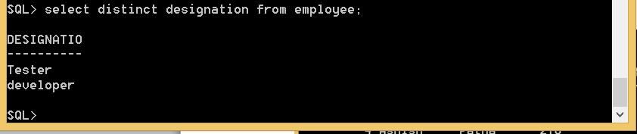

**3. List the emp who are working for the Deptno 10 or20.**

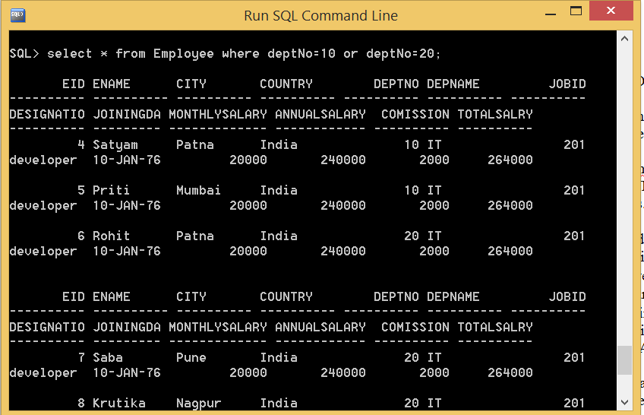

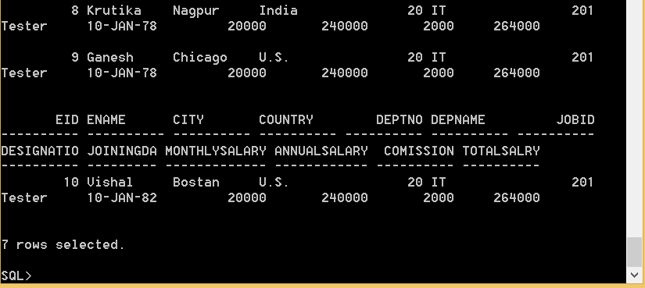

**4. List the emps who does not belong to Deptno 20.**

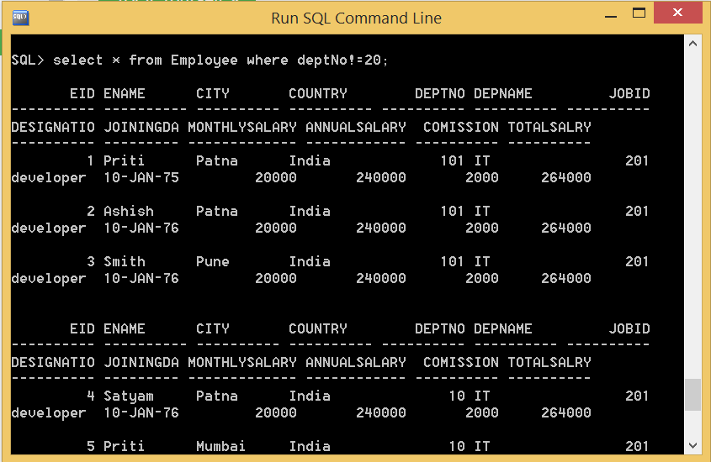

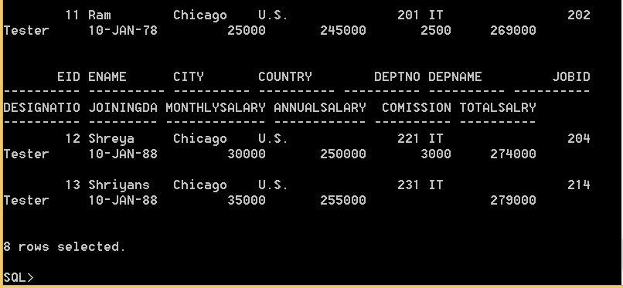

**5. List the emps who are working at CHICAGO & BOSTON.**

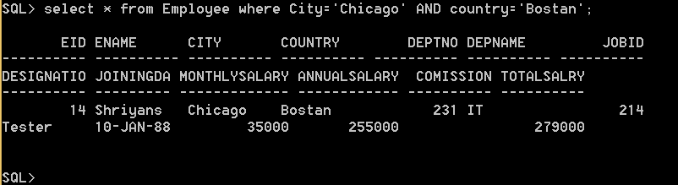

**6. List the emps in the descending order of their Salaries?**

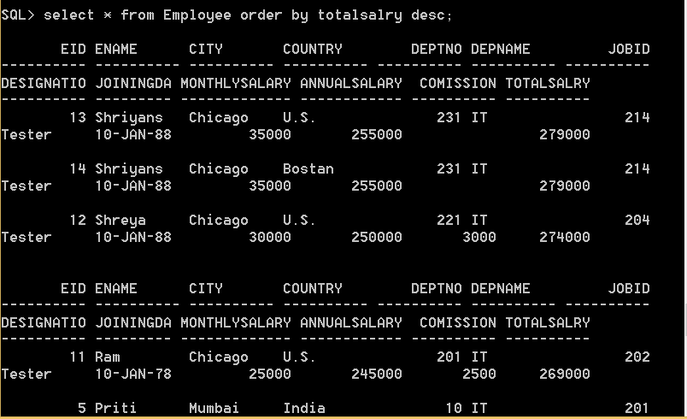

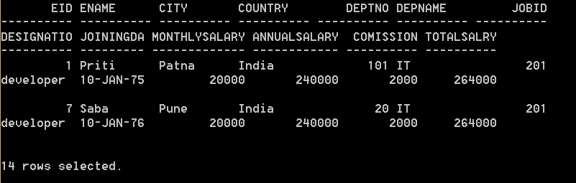

**7. List the details of the emps in asc order of the Dptnos and desc of Jobs?**

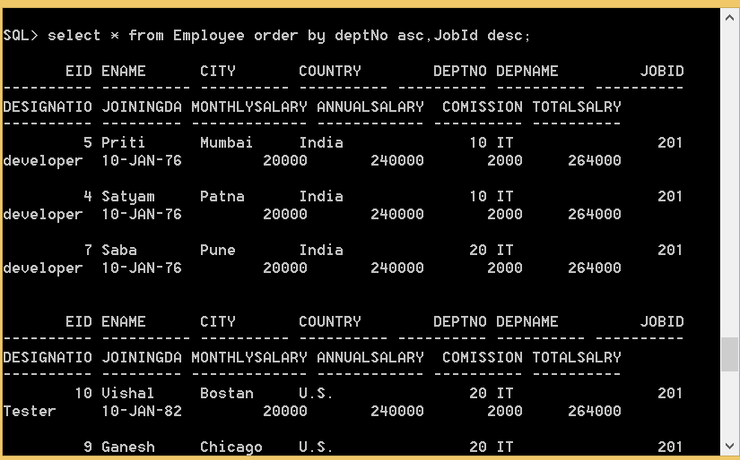

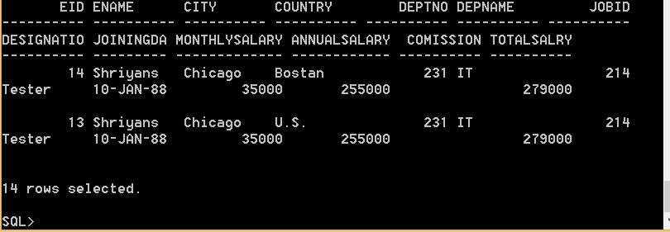

**8. Display all the unique job groups in the descending order?**

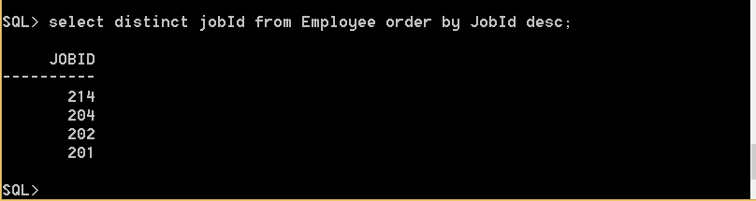

**9. List the emps who joined before 1981.**

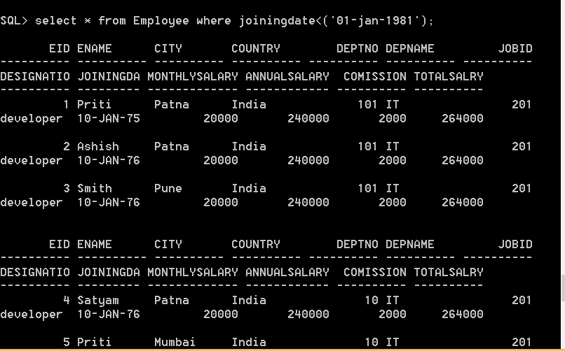

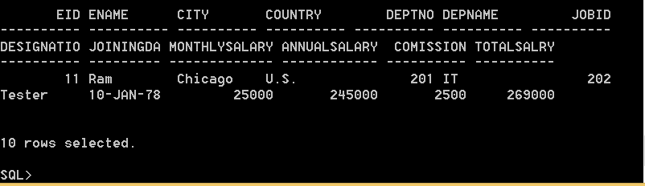

**10. List the Empno, Ename, Sal, Daily sal,Ann sal of all emps in the asc order of Annsal.**

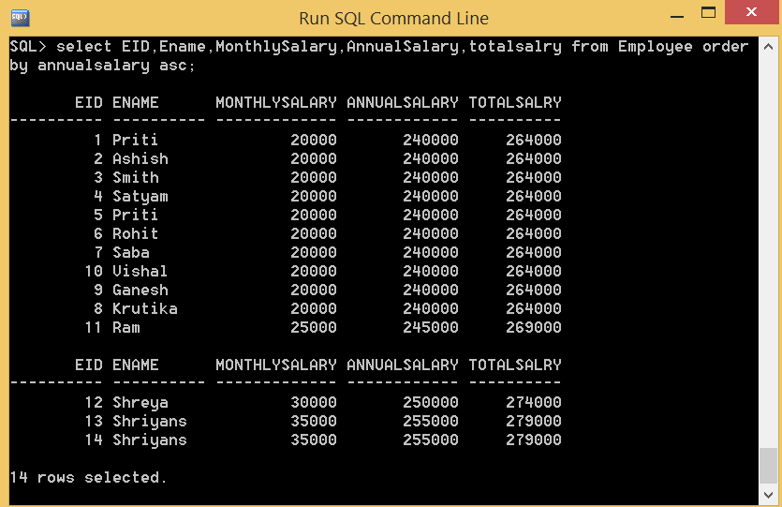

**11. Display all the details of the emps whose Comm is NULL.**

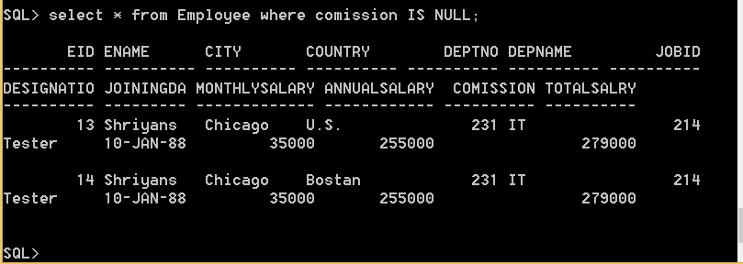

**12. Display empno,ename,comm,total sal of all employees.**

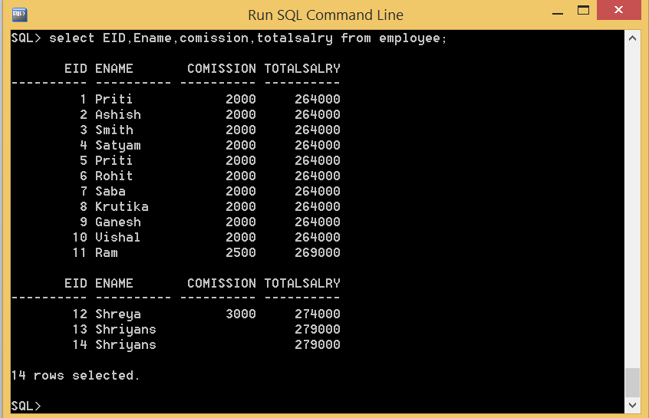

**14. List the emps Who Annual sal ranging from 22000 and 45000.**

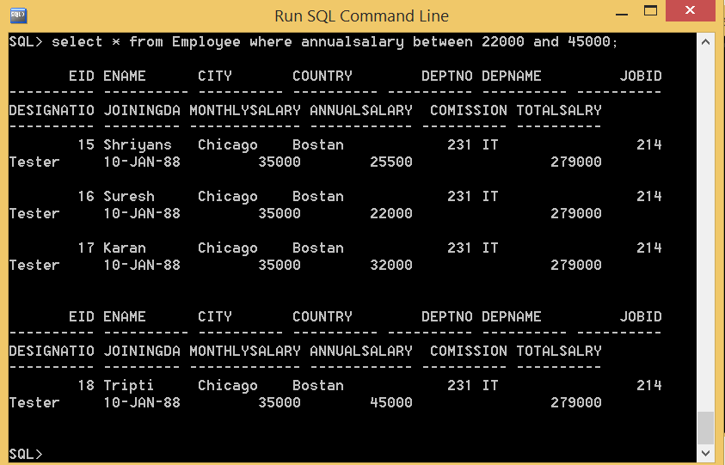

**15. List the Enames those are having five characters in their Names.**

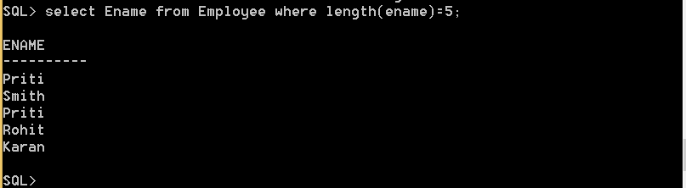

**16. List the Enames those are starting with ‘S’ and with five characters.**

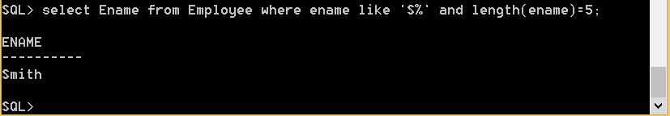

**GROUP BY (Solve any Five Queries)**

**1. Find the highest sal of EMP table**



**3. List the number of employees in each department.**

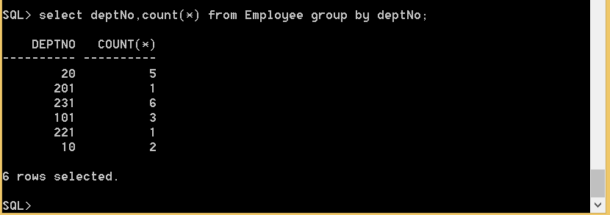

**4. List max,min,avg salary in each department.**

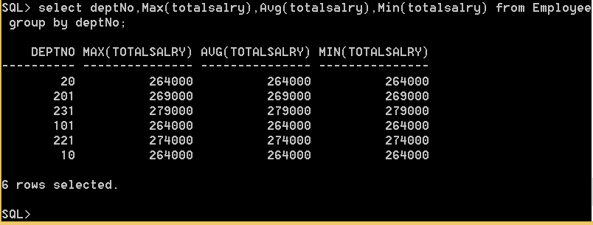

**6. List the depts. With atleast 3 emps.**

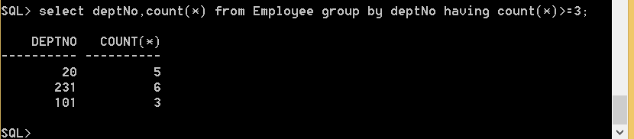

**7. List the Deptno where there are no emps.**

